Switch statements
I’m away again today, but here’s another tool to add to your coding toolkit.

SWITCH STATEMENTS
Work just like an IF-STATEMENT, except in certain situations, can clean up and make your code look much nicer. (Never underestimate the value of nice, clean written code!)

Here’s an if statement that checks what the day is:
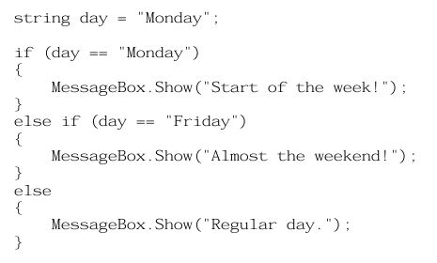
There should be nothing new about that code, we’ve worked with IF Statements a lot.
Here’s the same code, but using a SWITCH STATEMENT
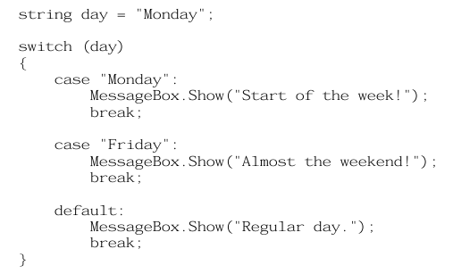

As you can see, we’re doing a SWITCH on the variable day.
Each case is a specific value we’re checking for.

Couple things to watch out for
- The regular colon ( : ) after the case. Don’t use a semi colon
- “break” after each case. Which kicks you out of the switch statement once you’ve found the correct case
- “default” which acts as the “default case”. Just like the “else” statement.
If no case is met, the default case will activate

Project
Create a program that allows the user to select a school subject from a group of radiobuttons. (Include at least 5 possible school courses)
Store the course they’ve selected in a variable called “course”
Create “submit” button that when clicked does the following:

Has a switch statement on “course” variable
- Display:
  - A custom message
  - A recommended career
  - A difficulty rating out of 10

Show the results in label

